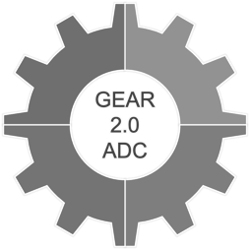
Recruitment, Engagement, and Retention (RER) Core Training Plan

About the RER Core
This Recruitment, Engagement, and Retention (RER) Core supports GEAR 2.0 – ADC pilot grantees in navigating challenges in participant recruitment, engagement, and retention. The RER Core provides training and guidance on (1) effective strategies for strengthening research accessibility and engagement, (2) approaches to improve participation among populations that are marginalized and/or historically under-represented in research, and (3) mechanisms for leveraging end-user/stakeholder feedback to refine recruitment practices. Members of the RER Core are also available to consult with grantees 1:1 to address specific challenges they encounter in recruitment, engagement, and/or retention in emergency care research.

The RER Core Team
Heidi Gil
Core Member
Manish Shah
Core Member
Angela Gifford
Administrative Support
Laura Block
Education Support
Andrea Gilmore-Bykovskyi
Core Lead
RER Core Training Plan and Approach
The RER Core Training Plan engages a scaffolding learning model with an emphasis on practical application of content to grantees individual projects. Training activities are designed to build sequentially across 3 interrelated training outcomes: (1) Establish a foundational understanding of principles of scientific inclusion and research equity, (2) Understand ways to cultivate a practice of reflection to proactively manage and refine recruitment, engagement, and retention practices, and (3) Engage in responsive end-user stakeholder feedback to guide actionable plans for RER improvement.

A representation of scaffolded training activities that build towards these 3 training outcomes across the 3 trimesters can be found below. Each trimester is further divided into content vs reflection modules, with seminar meetings and activities tailored accordingly. A detailed schedule can be found on the next page.

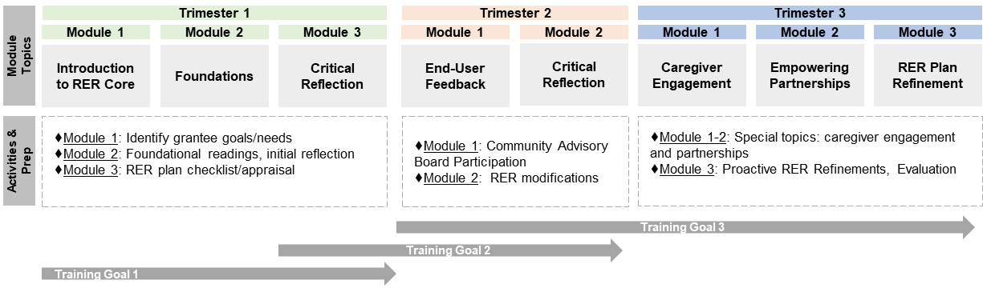
RER Core Seminar Schedule and Activities

Seminar  Date/Time  *All CST | Module Topic with Activities | Module Prep Work
Trimester 1
9/6, 12-12:30 pm | Module 1: Introduction to RER Core  ♦Introduction to RER Core  ♦Establish goals/needs  ♦Schedule CAB date | - Identify questions, needs, or goals related to RER for discussion during seminar  Post-Meeting Tasks:  - Send RER plan and recruitment materials to Dr. Gilmore-Bykovskyi (algilmore@wisc.edu)  - Identify respective team members who play critical role in RER  - Complete the Doodle poll by 9/9 to schedule your CARDS® meeting consultation (plan on attending a prep meeting with the CARDS® organizers 2 weeks prior to the CARDS® meeting itself)
10/25, 1-2 pm | Module 2: RER Foundations  ♦ Application discussion  ♦ RER appraisal – part 1 (completed during session) | - Required Readings. Please allot time to complete readings prior to our seminar as our time will be spent applying and building on this information. In order for this to be successful, everyone needs to come prepared.  - Gilmore-Bykovskyi et al. 2021. Traversing the Aging Research and Health Equity Divide: Toward Intersectional Frameworks of Research Justice and Participation.  - Friz et al. 2021. Tailoring Research Recruitment for Acute Care Settings: Recommendations from People with Dementia and their Caregivers. *Only pages 193-198*
11/29, 1-2 pm | Module 3: Critical Reflection and Application  ♦ RER appraisal – part 2 | - Complete checklist/appraisal of your study RER plan. Strongly Recommended: Engage your team in the appraisal.  - Supplementary Resources:  - Dilworth-Anderson. 2011. Introduction to the science of recruitment and retention among ethnically diverse populations.  - Passmore et al. 2021. "There's not much we can do…" researcher-level barriers to the inclusion of underrepresented participants in translational research.
Trimester 2
*Only formal RER meeting during Trimester 2 will be on 2/14
CARDS® Community Advisory Board Meetings | Module 1: End-User Feedback  ♦ No formal RER Seminars will be held 12/13, 01/24, or 3/21  ♦ In lieu of the 1.5 hours of prep and 3 hours of seminar time, each team will participate in their own CARDS® Community Advisory Board Meeting (includes 0.5-1 hour prep meeting, 2 hour CARDS® meeting) | - Review guidance on preparing for CARDS® meetings  - Each team to schedule and attend a CARDS® consultation/meeting by 2/14. Strongly Recommended: Have 1-2 key team members join the CARDS® meetings
2/14, 1-2 pm | Module 2: Critical Reflection and Appraisal  ♦ Discussion lessons learned  ♦ Potential RER Plan modifications | - Reflect on CARDS consultation/meeting  - Begin modifications to RER plan and materials based on CARDS consultation/meeting. Strongly Recommended: Engage team members in the modifications.
Trimester 3
*Trimester 3 activities will be modified based on grantee needs and interests
4/4, 1-2 pm | Module 1: Caregiver Engagement | - To be finalized
5/2, 1-2 pm | Module 1: Caregiver Engagement & Empowering Partnerships | - To be finalized
5/30, 1-2 pm | Module 2: RER Plan Refinement | - Proactive RER planning and modifications
6/20, 1-2 pm | Module 3: Evaluation and Feedback | - Evaluation and feedback

